BCCA is hosting a Water Licensing Seminar. If people haven't already/ or are confused on how to do it, or have troubles on the computer. Here is a great opportunity to get it done. On January 20, 2017 there will be 2 classes 9:00am-12:00pm and 1:00 pm- 4:00 pm, lets get your water licensing done. There will be no cost and this is open to all members of the cattlemens association and to anyone not a member but is looking to license. The seminar will be held at College of New Caladonia. Due to limited spacing registration is a must. To register contact Lyla Brophy 250-567-0403 or Liz Legebokoff 250-567-4787

Please bring this information with you or we can't help.

Here are the documents/information you will need to complete your application:

Proof of date of first use

This could be a well log or a signed statement that validates your date of first use.

• PID of your property

A Parcel Identifier, or PID, is a nine-digit number that uniquely identifies a parcel in the land title registry in BC. It can be found on your Rural Property Tax Notice or using your regional district mapping website.

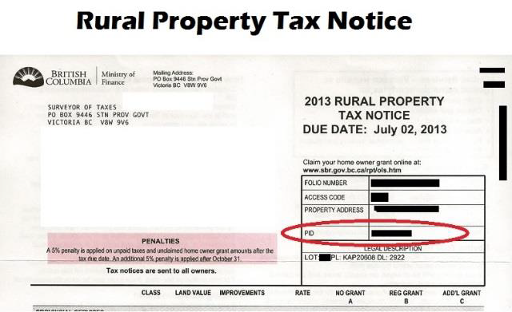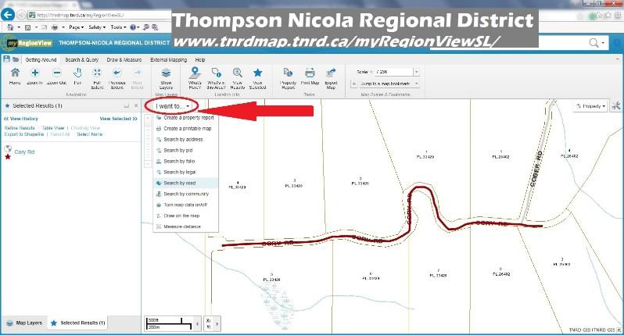

Legal description of your property

This can also be located on your Property Tax Assessment Notice (or via regional district mapping website). This is often written as a Lot#, Plan# (PL), and District Lot # (DL).

• Map/drawing

You will need a map or drawing showing the location of your well head, mainline or water trough. This can be a simple map.

• Geographic coordinates of your well

You will be required to enter the geographic coordinates in "Decimal Degree" format.

This can be found in a variety of ways. Using Google Earth or Google Maps may be the simplest. Search your address and using your mouse, click on the spot where your well is located. The coordinates are listed in the box.
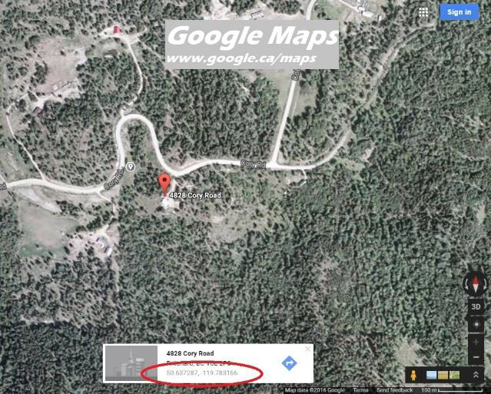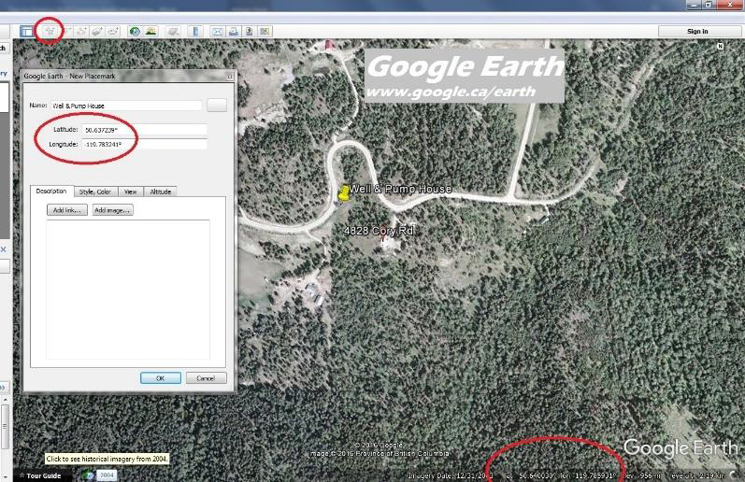

Volume of water you are applying for

You will need to calculate the volume of water that you are applying for. This needs to be done for each purpose that you are licensing (irrigation and/or stock watering).

A water calculator tool has been developed for BC agriculture that is easy to use.

http://www.bcagriculturewatercalculator.ca/

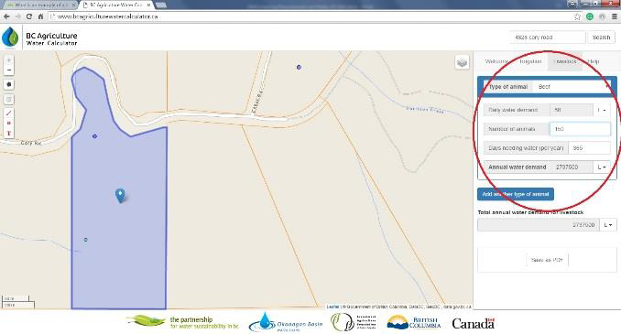

Determine if you have a BCeID

You may already have a BCeID for things such as a hunting licence or medical services plan. If you already have a BCeID, you don’t need a new one to apply for a groundwater licence.

If you do not already have a BCeID, we recommend that you apply for a Basic BCeID. To apply for a Basic BCeID visit the BCeID website: www.bceid.ca and click "Register" at the bottom of the page. You can start an application without a BCeID but you will not have the ability to come back to the application or make any changes.

If you can get this done as soon as possible would be great.

Sincerely Liz

